Er Manish Bhadoria’s Interactions Study Circle 10th CBSE Science

21. In the circuit diagram given here, the
current flowing in 5 ohm resistor is 1
ampere. Find the current flowing through
the other two resistors.
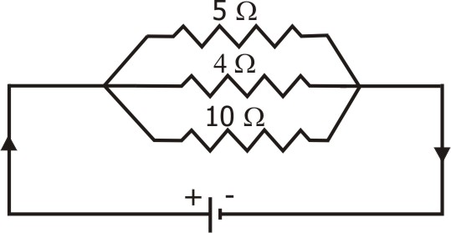

22. How will you connect three resistors of 2 W, 3 W and 5 W respectively so as
to obtain a resultant resistance of 2.5 W? Draw the diagram to show the
arrangement.

23. Suppose a 6-volt battery is connected
across a lamp, whose resistance is 20
ohm, through a variable resistor as
shown in fig. If the current in the
circuit is 0.25 A, calculate the value of
the resistance from the resistor which
must be used.

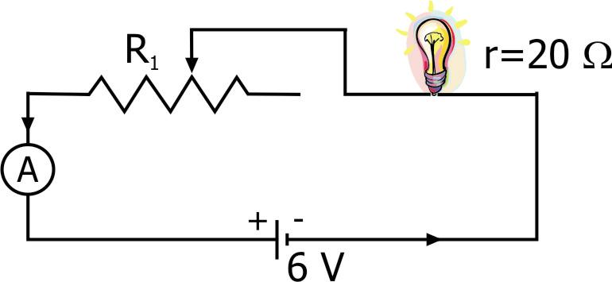

24. In the circuit diagram given in figure,
calculate:
(i) The current through each resistor,
(ii) The total current in the circuit, and
(iii) The total circuit resistance.
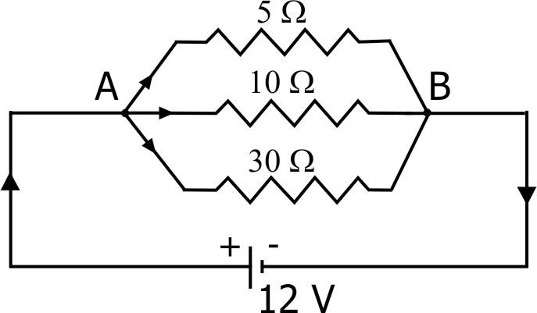

25. If you connect three resistors having values 2 W, 3 W and 5 W in parallel,
then, will the value of the total resistance be less than 2 W, or greater than 5
W, or lie between 2 W and 5 W? Explain.
26. Five dry cells each of 1.5 volt have internal resistance of 0.2, 0.3, 0.4, 0.5
and 12 ohms. When connected in series, what current will these five cells
furnish through 10 ohm resistance?
Er Manish Bhadoria’s Interactions Study Circle 10th CBSE Science

12 Electricity
(Problems Sheet – 2)

Problems on Combination of Resistances

1. If four resistances, each of value 1 ohm, are connected in series, what will
be the resultant resistance?
2. A resistance of 6 ohms is connected in series with another resistance of 4
ohms. A potential difference of 20 volts is applied across the combination.
Calculate the current through the circuit and potential difference across
the 6 ohm resistance.
3. Calculate the equivalent resistance when two resistances of 3 ohms and 6
ohms are connected in parallel.
4. How should the two resistances of 2 ohms each be connected so as to
produce an equivalent resistance of 1 ohm?
5. Three resistances of 12, 15 and 20 ohms are connected first in series and
then in parallel. What is the equivalent (or combined) resistance in each
case?
6. How can three resistors of 2, 3 and 6 ohms be connected in a circuit to give
a total resistance of 1 ohm?
7. What possible values of resistance are get by combining two resistance,
one of value 2 W and other 6 W?
8. If three resistances of 3 ohms each are connected in parallel, what will be
their total resistance?
9. In the circuit diagram, find:
(i) Total resistance
(ii) Current shown by the ammeter A.
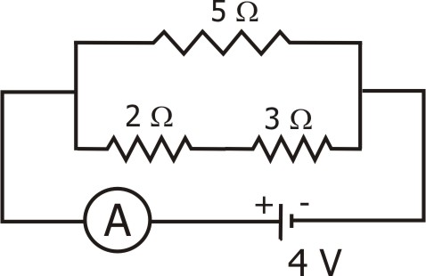

Er Manish Bhadoria’s Interactions Study Circle 10th CBSE Science

10. Two resistances when connected in parallel give resultant value of 2 ohm.
When they are connected in series, the value becomes 9 ohms. Calculate
the value of each resistance.

11. A resistor of 8 ohms is connected in parallel with another resistor X. the
resultant resistance of the combination is 4.8 ohms. What is the value of
the resistor X?
12. Two resistances are connected in
series as shown in the fig.
(i) What is the current through the 5
ohm resistance?
(ii) What is the current through R?
(iii) What is the value of R?
(iv) What is the value of V?
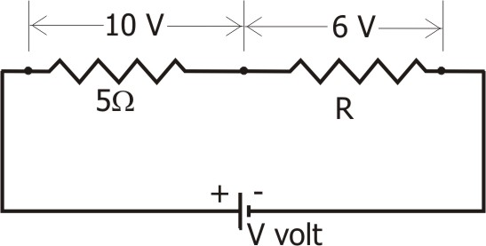

13. In the circuit diagram given here,
find:
(i) Total resistance of the circuit,
(ii) Total current flowing in the
circuit, and
(iii) The potential difference across
7.2 W resistance.
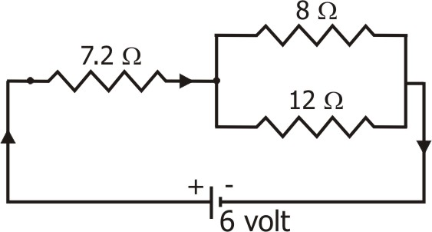

14. In the diagram, the cell and the
ammeter both have negligible
resistance. The resistors are
identical. With the switch K open,
the ammeter reads 0.6 A. What will
be the ammeter reading when the
switch is closed?
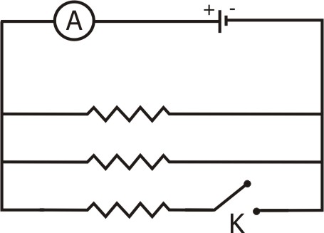

15. Three resistors are connected as shown in the diagram. Through the
resistor 5 ohm, a current of 1 ampere is flowing.
Er Manish Bhadoria’s Interactions Study Circle 10th CBSE Science

(i) What is the current through
other two resistors?
(ii) What is the p.d. across AB
and across AC?
(iii) What is the total resistance?

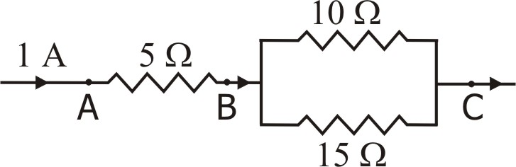

16. For the circuit shown in the following
diagram, find the value of:
(i) Current through 6 W resistor.
(ii) Potential difference across 12 W resistor.
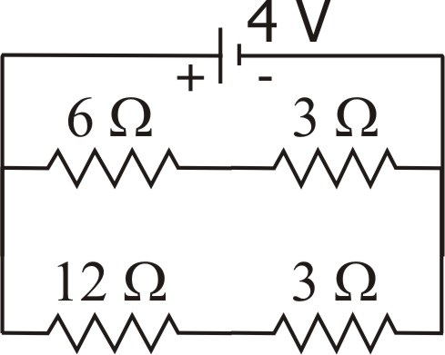

17. Two resistors X and Y are connected turn by turn: (i) in parallel, and (ii) in
series. In which case the resultant resistance will be less than either of the
individual resistances?
18. You are given three resistances of 1, 2 and 3 ohms. Show by diagrams,
how with the help of these resistances you can get:
(i) 6 W, (ii) 6/11 W, (iii) 1.5 W, (iv) 4/3 W, (v) 5/6 W, (vi) 11/5 W, (vii) 11/4 W,
(viii) 11/3 W
19. Four resistances of equal value 1 ohm are given. Show by diagrams all
different variations in which these four resistances can be connected.
Calculate in each case the resultant resistance of the combination. In which
case is the total resistance highest and in which it is lowest?

20. The circuit diagram here shows the
combination of three resistors. Find:
(i) Total resistance of the circuit.
(ii) Total current flowing in the circuit.
(iii) Potential difference across 4 W
resistor.
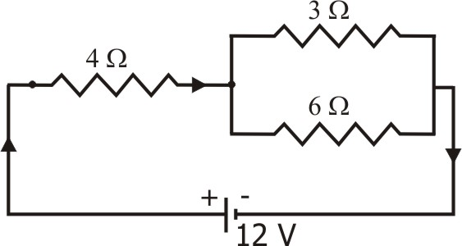

Er Manish Bhadoria’s Interactions Study Circle 10th CBSE Science

27. Calculate the effective resistance
between the points A and B in the
network shown here.
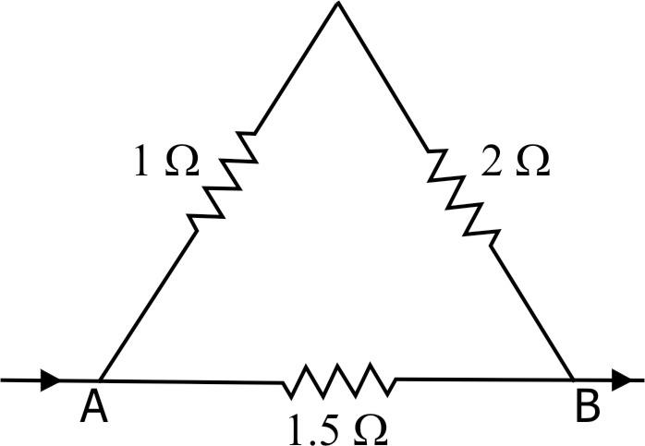

28. Calculate the effective resistance in the
diagram shown in figure.
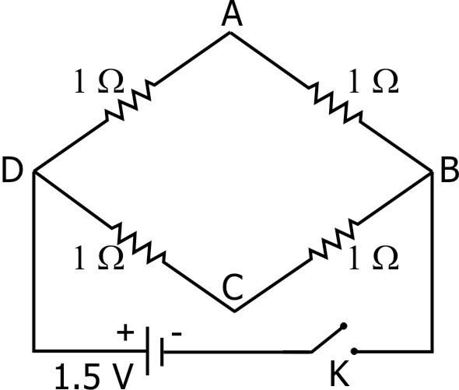

29. In the circuit given find the current
through each resistor.
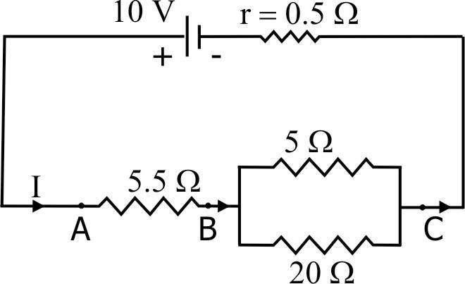

30. When two resistances are connected in series, their combined resistance is
25 ohms and when they are connected in parallel, their combined
resistance is 4 ohms. Find their individual resistance.

31. In the circuit shown in figure, calculate
(i) The current flowing through the
arms AB, AC and CDE.
(ii) The potential difference across AB,
CD and DE.
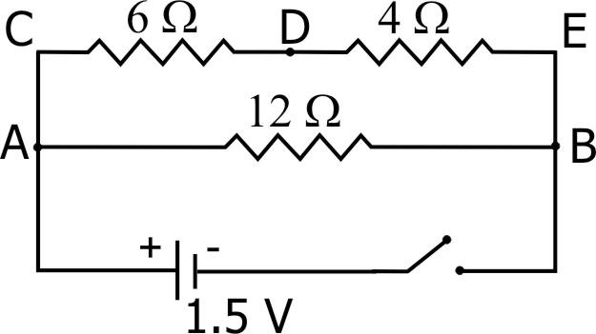

Er Manish Bhadoria’s Interactions Study Circle 10th CBSE Science

32. Four resistances of 16 ohms each are connected in parallel. Four such
combinations are connected in series. What is the total resistance?

33. Six equal resistors of 1 W each are connected to form the sides of a hexagon
ABCDEFG. Calculate the resistance offered by the combination if the
current:
(i) Enters at A and leaves at B.
(ii) Enters at A and leaves at C.
(iii) Enters at A and leaves at D.
34. Calculate the equivalent
resistance of the combination
of resistances shown in
figure.
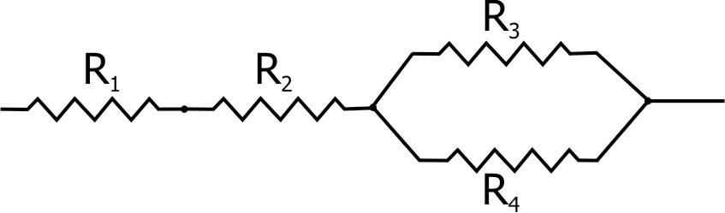

35. Calculate the effective
resistance between the points
A and B in the circuit shown
in figure.
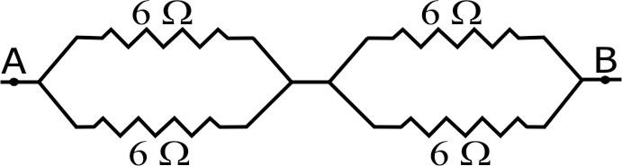

36. In the circuit shown
here, calculate the
equivalent resistance
between the points A
and B.
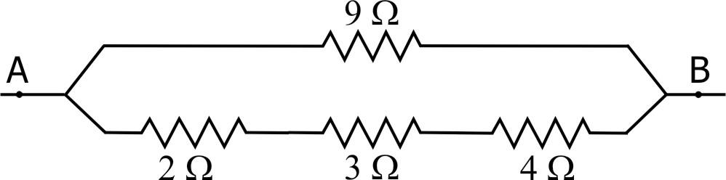

37. A circuit is set up as shown in
figure. Calculate the current
through and the potential
difference across R1, R2 and R3,
when:
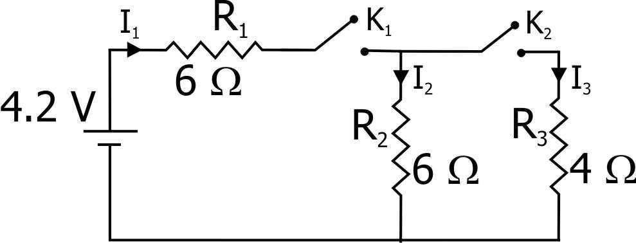

(i) Keys K1 and K2 both are closed.
(ii) Key K1 is closed and K2 is opened.
(iii) Key K1 is opened and K2 is closed. ---------- x ----------

