Magnetic Effects of Electric Current
Question 1: Why does a compass needle get deflected when brought near a bar magnet?

Answer: A compass needle is a small bar magnet. When it is brought near a bar magnet, its
magnetic field lines interact with that of the bar magnet. Hence, a compass needle shows a
deflection when brought near the bar magnet.

Question 2: Draw magnetic field lines around a bar magnet.

Answer: Magnetic field lines of a bar magnet emerge from the north pole and terminate at the
south pole. Inside the magnet, the field lines emerge from the south pole and terminate at the north

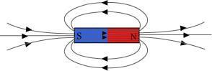

Question 3: List the properties of magnetic lines of force.
Answer: The properties of magnetic lines of force are as follows.

(a) Magnetic field lines emerge from the north pole.

(b) They merge at the south pole.

(c) The direction of field lines inside the magnet is from the south pole to the north pole.

(d) Magnetic lines do not intersect with each other.

Question 4: Why don’t two magnetic lines of force intersect each other?

Answer: If two field lines of a magnet intersect, then at the point of intersection, the compass
needle points in two different directions. This is not possible. Hence, two field lines do not

Question 5: Consider a circular loop of wire lying in the plane of the table. Let the current pass
through the loop clockwise. Apply the right-hand rule to find out the direction of the magnetic

Answer: Inside the loop = Pierce inside the table

Outside the loop = Appear to emerge out from the table

For downward direction of current flowing in the circular loop, the direction of magnetic field lines
will be as if they are emerging from the table outside the loop and merging in the table inside the
loop. Similarly, for upward direction of current flowing in the circular loop, the direction of
magnetic field lines will be as if they are emerging from the table outside the loop and merging in
Downloaded from : http://www.cbsesmart.com
Downloaded from : http://www.cbsesmart.com

field inside and outside the loop.
intersect each other.
pole, as shown in the given figure.

the table inside the loop, as shown in the given figure.

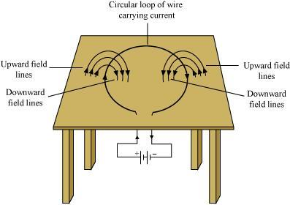

Question 6: The magnetic field in a given region is uniform. Draw a diagram to represent it.

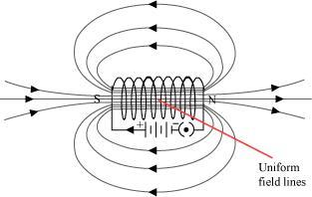

The magnetic field lines inside a current-carrying long straight solenoid are uniform.

Question 7: Consider a circular loop of wire lying in the plane of the table. Let the current pass
through the loop clockwise. Apply the right-hand rule to find out the direction of the magnetic

Answer: Inside the loop = Pierce inside the table

Outside the loop = Appear to emerge out from the table

For downward direction of current flowing in the circular loop, the direction of magnetic field lines
will be as if they are emerging from the table outside the loop and merging in the table inside the
loop. Similarly, for upward direction of current flowing in the circular loop, the direction of
magnetic field lines will be as if they are emerging from the table outside the loop and merging in
the table inside the loop, as shown in the given figure.

Downloaded from : http://www.cbsesmart.com
Downloaded from : http://www.cbsesmart.com

field inside and outside the loop.

Question 8:

The magnetic field in a given region is uniform. Draw a diagram to represent it.

The magnetic field lines inside a current-carrying long straight solenoid are uniform.

Question 9: Choose the correct option.

The magnetic field inside a long straight solenoid-carrying current

(a) is zero

(b) decreases as we move towards its end

(c) increases as we move towards its end

(d) is the same at all points

Answer: (d) The magnetic field inside a long, straight, current-carrying solenoid is uniform. It is
the same at all points inside the solenoid.

Question 10: Which of the following property of a proton can change while it moves freely in a
magnetic field? (There may be more than one correct answer.)

Answer:

(a) mass

(b) speed

(c) velocity

(d) momentum

Answer: (c) and (d)

When a proton enters in a region of magnetic field, it experiences a magnetic force. As a result of
the force, the path of the proton becomes circular. Hence, its velocity and momentum change.

Question 11: State Fleming’s left-hand rule.

Answer: Fleming’s left hand rule states that if we arrange the thumb, the centre finger, and the
forefinger of the left hand at right angles to each other, then the thumb points towards the direction
of the magnetic force, the centre finger gives the direction of current, and the forefinger points in

Question 12: What is the principle of an electric motor?

Answer: The working principle of an electric motor is based on the magnetic effect of current. A
current-carrying loop experiences a force and rotates when placed in a magnetic field. The
direction of rotation of the loop is given by the Fleming’s left-hand rule.

Question 13: What is the role of the split ring in an electric motor?

Answer: The split ring in the electric motor acts as a commutator. The commutator reverses the
direction of current flowing through the coil after each half rotation of the coil. Due to this reversal
of the current, the coil continues to rotate in the same direction.

Question 14: Explain different ways to induce current in a coil.

Answer: The different ways to induce current in a coil are as follows:

(a) If a coil is moved rapidly between the two poles of a horse-shoe magnet, then an electric
current is induced in the coil.

(b) If a magnet is moved relative to a coil, then an electric current is induced in the coil.

Question 15: State the principle of an electric generator.

Answer: An electric generator works on the principle of electromagnetic induction. It generates
electricity by rotating a coil in a magnetic field.

Question 16: Name some sources of direct current.

Answer: Some sources of direct current are cell, DC generator, etc.

Question 17: Which sources produce alternating current?

Downloaded from : http://www.cbsesmart.com
Downloaded from : http://www.cbsesmart.com

the direction of magnetic field.

Answer: AC generators, power plants, etc., produce alternating current.

Question 18: Choose the correct option.

Answer: A rectangular coil of copper wires is rotated in a magnetic field. The direction of the

(a) two revolutions

(c) half revolution

(c) When a rectangular coil of copper is rotated in a magnetic field, the direction of the induced
current in the coil changes once in each half revolution. As a result, the direction of current in the

Question 19: Name two safety measures commonly used in electric circuits and appliances.

Answer: Two safety measures commonly used in electric circuits and appliances are as follows:

(i) Each circuit must be connected with an electric fuse. This prevents the flow of excessive
current through the circuit. When the current passing through the wire exceeds the maximum limit
of the fuse element, the fuse melts to stop the flow of current through that circuit, hence protecting

(ii) Earthing is a must to prevent electric shocks. Any leakage of current in an electric appliance is

Question 20: An electric oven of 2 kW is operated in a domestic electric circuit (220 V) that has a

Answer: Current drawn by the electric oven can be obtained by the expression,

P = VI

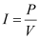

Where,

Current = I

Power of the oven, P = 2 kW = 2000 W

Voltage supplied, V = 220 V

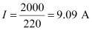

Hence, the current drawn by the electric oven is 9.09 A, which exceeds the safe limit of the
circuit. Fuse element of the electric fuse will melt and break the circuit.

Question 21: What precaution should be taken to avoid the overloading of domestic electric
Downloaded from : http://www. cbsesmart.com
Downloaded from : http://www. cbsesmart.com

current rating of 5 A. What result do you expect? Explain.
transferred to the ground and people using the appliance do not get the shock.
the appliances connected to the circuit.
coil remains the same.
(b) one revolution
(d) one-fourth revolution
induced current changes once in each

circuits?

Answer: The precautions that should be taken to avoid the overloading of domestic circuits are as

(a) Too many appliances should not be connected to a single socket.

(b) Too many appliances should not be used at the same time.

(c) Faulty appliances should not be connected in the circuit.

(d) Fuse should be connected in the circuit.

Question 22: Which of the following correctly describes the magnetic field near a long straight

(a) The field consists of straight lines perpendicular to the wire

(b) The field consists of straight lines parallel to the wire

(c) The field consists of radial lines originating from the wire

(d) The field consists of concentric circles centred on the wire

Answer: (d) The magnetic field lines, produced around a straight current-carrying conductor, are

Question 23: The phenomenon of electromagnetic induction is

(a) the process of charging a body

(b) the process of generating magnetic field due to a current passing through a coil

(c) producing induced current in a coil due to relative motion between a magnet and the coil

(d) the process of rotating a coil of an electric motor

Answer: (c) When a straight coil and a magnet are moved relative to each other, a current is
induced in the coil. This phenomenon is known as electromagnetic induction.

Question 24: The device used for producing electric current is called a

(a) generator

(b) galvanometer

(c) ammeter

(d) motor

Answer: (a) An electric generator produces electric current. It converts mechanical energy into
Downloaded from : http://www. cbsesmart.com
Downloaded from : http://www. cbsesmart.com

electricity.
concentric circles. Their centres lie on the wire.
wire?
follows:

Question 25: The essential difference between an AC generator and a DC generator is that

(a) AC generator has an electromagnet while a DC generator has permanent magnet.

(b) DC generator will generate a higher voltage.

(c) AC generator will generate a higher voltage.

(d) AC generator has slip rings while the DC generator has a commutator.

Answer: (d) An AC generator has two rings called slip rings. A DC generator has two half rings
called commutator. This is the main difference between both the types of generators.

Question 26: At the time of short circuit, the current in the circuit

(a) reduces substantially

(b) does not change

(c) increases heavily

(d) vary continuously

Answer: (c) When two naked wires of an electric circuit touch each other, the amount of current
that is flowing in the circuit increases abruptly. This causes short-circuit.

Question 27: State whether the following statements are true or false.

(a) An electric motor converts mechanical energy into electrical energy.

(b) An electric generator works on the principle of electromagnetic induction.

(c) The field at the centre of a long circular coil carrying current will be parallel straight lines.

(d) A wire with a green insulation is usually the live wire of an electric supply.

Answer: (a) False

An electric motor converts electrical energy into mechanical energy.

(b) True

A generator is an electric device that generates electricity by rotating a coil in a magnetic field. It

(c) True

A long circular coil is a long solenoid. The magnetic field lines inside the solenoid are parallel lines.

(d) False

Downloaded from : http://www. cbsesmart.com
Downloaded from : http://www. cbsesmart.com

works on the principle of electromagnetic induction.

Live wire has red insulation cover, whereas earth wire has green insulation colour in the domestic

Question 28: List three sources of magnetic fields.

Answer: Three sources of magnetic fields are as follows:

(a) Current-carrying conductors

(b) Permanent magnets

(c) Electromagnets

Question 29: How does a solenoid behave like a magnet? Can you determine the north and south
poles of a current-carrying solenoid with the help of a bar magnet? Explain.

Answer: A solenoid is a long coil of circular loops of insulated copper wire. Magnetic field lines
are produced around the solenoid when a current is allowed to flow through it. The magnetic field
produced by it is similar to the magnetic field of a bar magnet. The field lines produced in a
current-carrying solenoid is shown in the following figure.

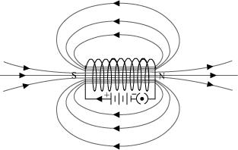

In the above figure, when the north pole of a bar magnet is brought near the end connected to the
negative terminal of the battery, the solenoid repels the bar magnet. Since like poles repel each
other, the end connected to the negative terminal of the battery behaves as the north pole of the
solenoid and the other end behaves as a south pole. Hence, one end of the solenoid behaves as a
north pole and the other end behaves as a south pole.
Question 30: When is the force experienced by a current-carrying conductor placed in a magnetic
field largest?

Answer: The force experienced by a current-currying conductor is the maximum when the
direction of current is perpendicular to the direction of the magnetic field.

Question 31: Imagine that you are sitting in a chamber with your back to one wall. An electron
beam, moving horizontally from back wall towards the front wall, is deflected by a strong magnetic
field to your right side. What is the direction of magnetic field?

Answer: The direction of magnetic field is given by Fleming’s left hand rule. Magnetic field inside
the chamber will be perpendicular to the direction of current (opposite to the direction of electron)
and direction of deflection/force i.e., either upward or downward. The direction of current is from
Downloaded from : http://www. cbsesmart.com
Downloaded from : http://www. cbsesmart.com

circuits.

the front wall to the back wall because negatively charged electrons are moving from back wall to
the front wall. The direction of magnetic force is rightward. Hence, using Fleming’s left hand rule,
it can be concluded that the direction of magnetic field inside the chamber is downward.

Question 32: Imagine that you are sitting in a chamber with your back to one wall. An electron
beam, moving horizontally from back wall towards the front wall, is deflected by a strong magnetic
field to your right side. What is the direction of magnetic field?

Answer: The direction of magnetic field is given by Fleming’s left hand rule. Magnetic field inside
the chamber will be perpendicular to the direction of current (opposite to the direction of electron)
and direction of deflection/force i.e., either upward or downward. The direction of current is from
the front wall to the back wall because negatively charged electrons are moving from back wall to
the front wall. The direction of magnetic force is rightward. Hence, using Fleming’s left hand rule,
it can be concluded that the direction of magnetic field inside the chamber is downward.

Question 33: Draw a labelled diagram of an electric motor. Explain its principle and working.
What is the function of a split ring in an electric motor?

Answer: An electric motor converts electrical energy into mechanical energy.

It works on the principle of the magnetic effect of current. A current-carrying coil rotates in a

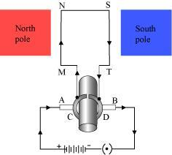

When a current is allowed to flow through the coil MNST by closing the switch, the coil starts
rotating anti-clockwise. This happens because a downward force acts on length MN and at the
same time, an upward force acts on length ST. As a result, the coil rotates anti-clockwise.

Current in the length MN flows from M to N and the magnetic field acts from left to right, normal
to length MN. Therefore, according to Fleming’s left hand rule, a downward force acts on the
length MN. Similarly, current in the length ST flows from S to T and the magnetic field acts from
left to right, normal to the flow of current. Therefore, an upward force acts on the length ST. These

After half a rotation, the position of MN and ST interchange. The half-ring D comes in contact
with brush A and half-ring C comes in contact with brush B. Hence, the direction of current in the

Downloaded from : http://www. cbsesmart.com
Downloaded from : http://www. cbsesmart.com

coil MNST gets reversed.
two forces cause the coil to rotate anti-clockwise.
magnetic field. The following figure shows a simple electric motor.

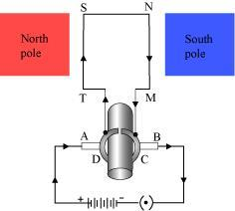

The current flows through the coil in the direction TSNM. The reversal of current through the coil
MNST repeats after each half rotation. As a result, the coil rotates unidirectional. The split rings

Question 34: Name some devices in which electric motors are used?

Answer: Some devices in which electric motors are used are as follows:

(a) Water pumps

(b) Electric fans

(c) Electric mixers

(d) Washing machines

Question 35: A coil of insulated copper wire is connected to a galvanometer. What will happen if
a bar magnet is (i) pushed into the coil, (ii) withdrawn from inside the coil, (iii) held stationary

Answer: A current induces in a solenoid if a bar magnet is moved relative to it. This is the

(i) When a bar magnet is pushed into a coil of insulated copper wire, a current is induced
momentarily in the coil. As a result, the needle of the galvanometer deflects momentarily in a

(ii) When the bar magnet is withdrawn from inside the coil of the insulated copper wire, a current
is again induced momentarily in the coil in the opposite direction. As a result, the needle of the

(iii) When a bar magnet is held stationary inside the coil, no current will be induced in the coil.

Question 36: Two circular coils A and B are placed closed to each other. If the current in the coil
A is changed, will some current be induced in the coil B? Give reason.

Answer: Two circular coils A and B are placed close to each other. When the current in coil A is
changed, the magnetic field associated with it also changes. As a result, the magnetic field around
coil B also changes. This change in magnetic field lines around coil B induces an electric current in
Downloaded from : http://www. cbsesmart.com
Downloaded from : http://www. cbsesmart.com

Hence, galvanometer will show no deflection.
galvanometer deflects momentarily in the opposite direction.
particular direction.
principle of electromagnetic induction.
inside the coil?
help to reverse the direction of current in the circuit. These are called the commutator.

it. This is called electromagnetic induction.

Question 37: State the rule to determine the direction of a (i) magnetic field produced around a
straight conductor-carrying current, (ii) force experienced by a current-carrying straight conductor
placed in a magnetic field which is perpendicular to it, and (iii) current induced in a coil due to its

Answer: (i) Maxwell’s right hand thumb rule

(ii) Fleming’s left hand rule

(iii) Fleming’s right hand rule

Question 38: Explain the underlying principle and working of an electric generator by drawing a

Answer: An electric generator converts mechanical energy into electrical energy.

The principle of working of an electric generator is that when a loop is moved in a magnetic field,
an electric current is induced in the coil. It generates electricity by rotating a coil in a magnetic

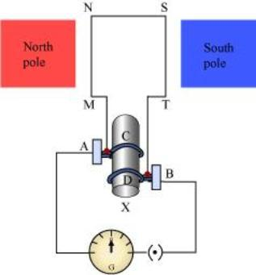

MNST → Rectangular coil

A and B → Brushes

C and D → Two slip rings

X → Axle, G → Galvanometer

If axle Xis rotated clockwise, then the length MN moves upwards while length ST moves
downwards. Since the lengths MN and ST are moving in a magnetic field, a current will be induced
in both of them due to electromagnetic induction. Length MN is moving upwards and the magnetic
Downloaded from : http://www. cbsesmart.com
Downloaded from : http://www. cbsesmart.com

field. The following figure shows a simple AC generator.
labelled diagram. What is the function of brushes?
rotation in a magnetic field.

field acts from left to right. Hence, according to Fleming’s right hand rule, the direction of induced
current will be from M to N. Similarly, the direction of induced current in the length ST will be

The direction of current in the coil is MNST. Hence, the galvanometer shows a deflection in a
particular direction. After half a rotation, length MN starts moving down whereas length ST starts
moving upward. The direction of the induced current in the coil gets reversed as TSNM. As the
direction of current gets reversed after each half rotation, the produced current is called an

To get a unidirectional current, instead of two slip rings, two split rings are used, as shown in the

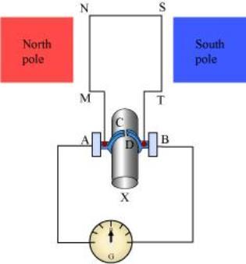

In this arrangement, brush A always remains in contact with the length of the coil that is moving
up whereas brush B always remains in contact with the length that is moving down. The split rings

The direction of current induced in the coil will be MNST for the first rotation and TSNM in the
second half of the rotation. Hence, a unidirectional current is produced from the generator called
DC generator. The current is called AC current.

Question 39: When does an electric short circuit occur?

When the insulation of live and neutral wires undergoes wear and tear and then touches each
other, the current flowing in the circuit increases abruptly. Hence, a short circuit occurs.

Question 40: What is the function of an earth wire? Why is it necessary to earth metallic
appliances?
Downloaded from : http://www. cbsesmart.com
Answer: The metallic body of electric appliances is connected to the earth by means of earth wire
so that any leakage of electric current is transferred to the ground. This prevents any electric shock

to the user. That is why earthing of the electrical appliances is necessary.
the circuit becomes very high. This is caused by connecting too many appliances to a single socket
Answer: If the resistance of an electric circuit becomes very low, then the current flowing through
Or connecting high power rating appliances to the light circuits. This results in a short circuit.

C and D act as a commutator.
Fo llowing figure.
alternating current (AC).
from S to T.

