Material downloaded from http://www.cbsesmart.weebly.com. A portal for CBSE Notes, Test
Papers, Sample Papers, assignments with tips and tricks Page 1

X Science Questions From CBSE Examination Papers Ch: Magnetic Effect of currents
1)

2)

3)
4)

5)

6)

7)

8)

9)

10)

11)

12)

13)

14) 1
4
)

X Science Questions From CBSE Examination Papers Ch: Magnetic Effect of currents
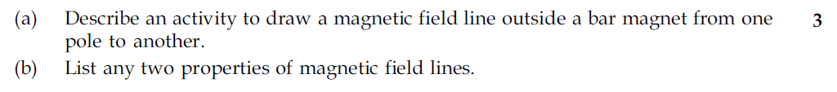
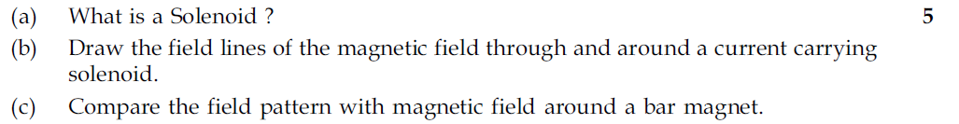
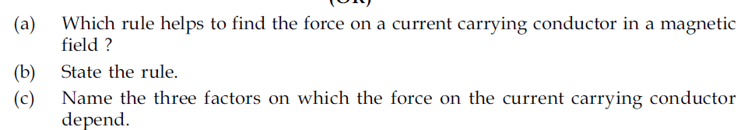
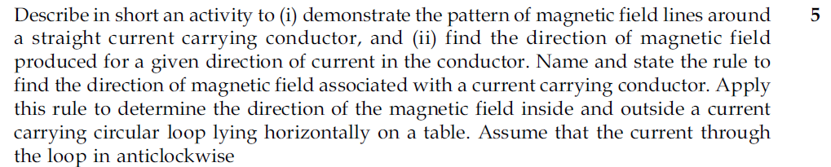
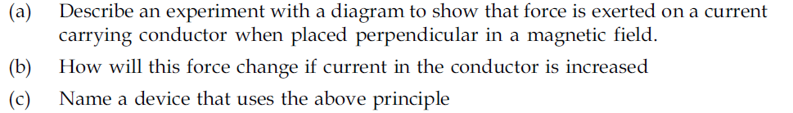
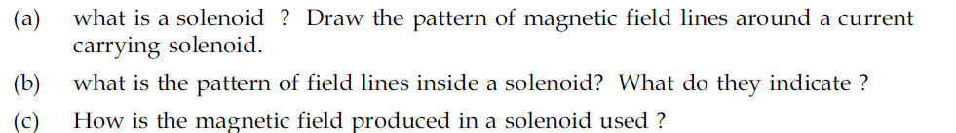
X Science Questions From CBSE Examination Papers Ch: Magnetic Effect of currents

Material downloaded from http://www.cbsesmart.weebly.com. A portal for CBSE Notes, Test
Papers, Sample Papers, assignments with tips and tricks Page 2

X Science Questions From CBSE Examination Papers Ch: Magnetic Effect of currents
1)

2)

3)

4)

5)

6)

7)

8)

9)

10)

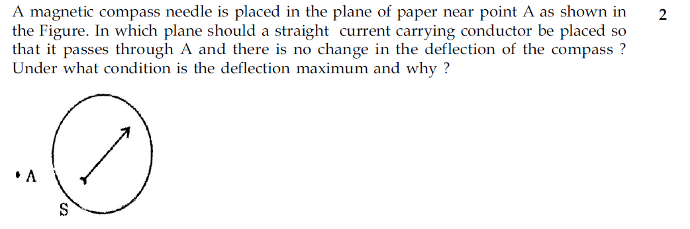
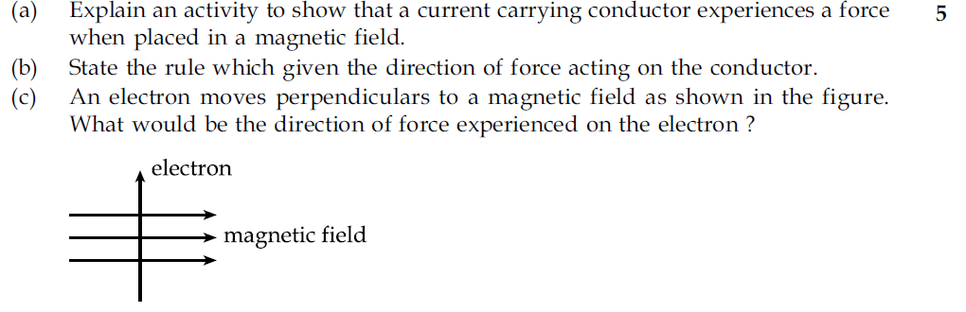
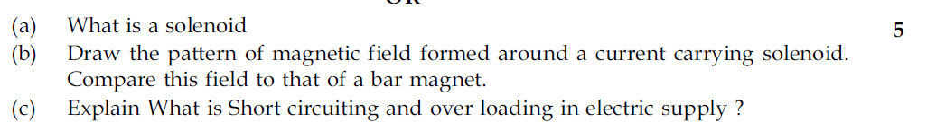
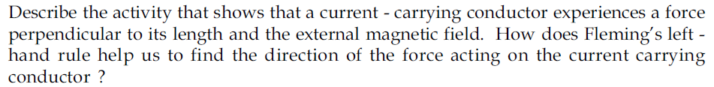
X Science Questions From CBSE Examination Papers Ch: Magnetic Effect of currents

Material downloaded from http://www.cbsesmart.weebly.com. A portal for CBSE Notes, Test
Papers, Sample Papers, assignments with tips and tricks Page 3

Questions From CBSE Examination Papers Ch: Magnetic Effect of currents
1)

2)

3)

4)

5)

6)

7)

8)

9)

10)

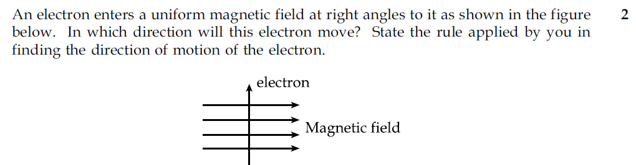
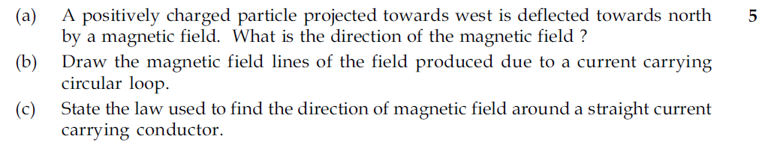
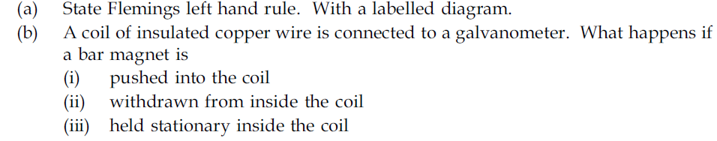
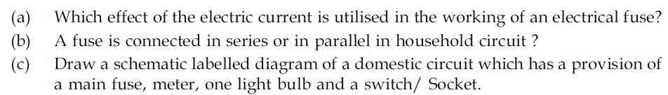
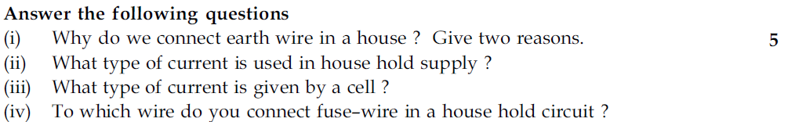
X Science Questions From CBSE Examination Papers Ch: Magnetic Effect of currents

Material downloaded from http://www.cbsesmart.weebly.com. A portal for CBSE Notes, Test
Papers, Sample Papers, assignments with tips and tricks Page 4

Questions From CBSE Examination Papers Ch: Magnetic Effect of currents
1)
2)

3)

4)

5)

6)

7)

8)

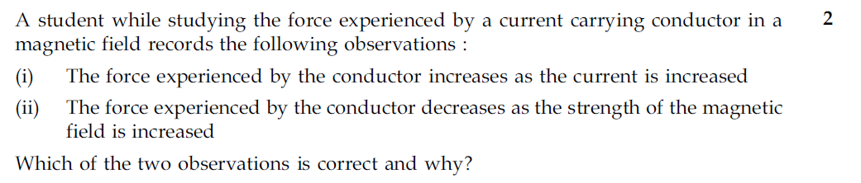
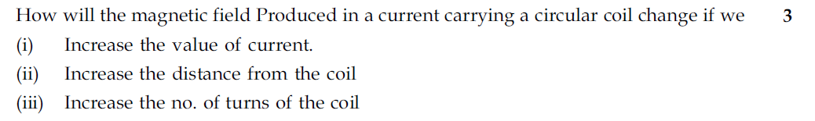
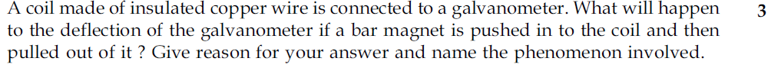
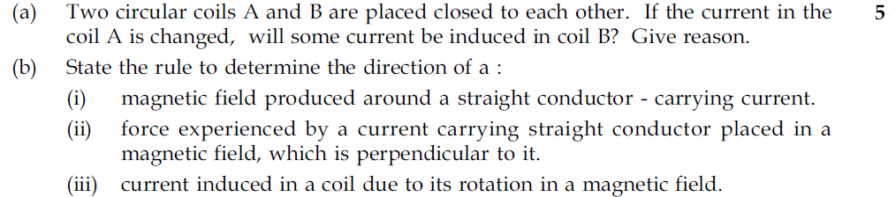
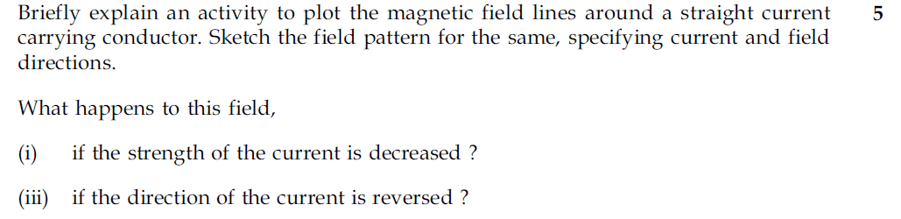
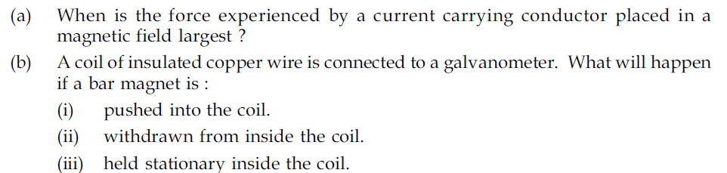
X Science Questions From CBSE Examination Papers Ch: Magnetic Effect of currents

Material downloaded from http://www.cbsesmart.weebly.com. A portal for CBSE Notes, Test
Papers, Sample Papers, assignments with tips and tricks Page 5

X Science Questions From CBSE Examination Papers Ch: Magnetic Effect of currents
1)

2)
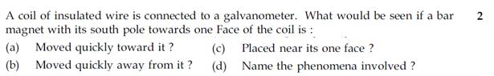

3)

4)

5)
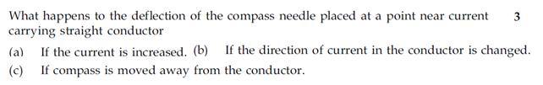

6)

7)

8)

9)

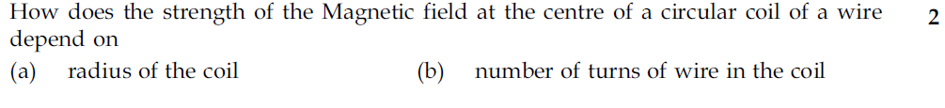
X Science Questions From CBSE Examination Papers Ch: Magnetic Effect of currents
