www.cbsesmart.weebly.com

Pa
ge
1

10th Chapter: Electricity and Heating Effect of Current Numerial With Answer

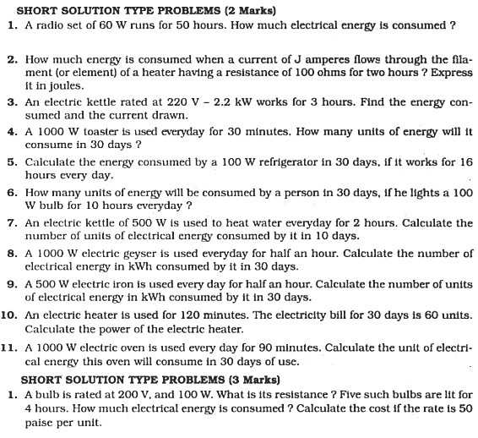
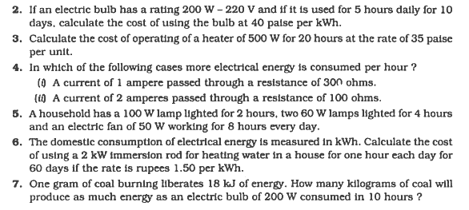
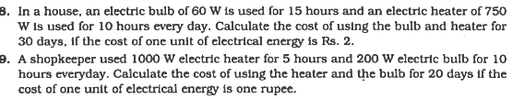

www.cbsesmart.weebly.com

Pa
ge
2

